**CIRCUIT DIAGRAM:-**

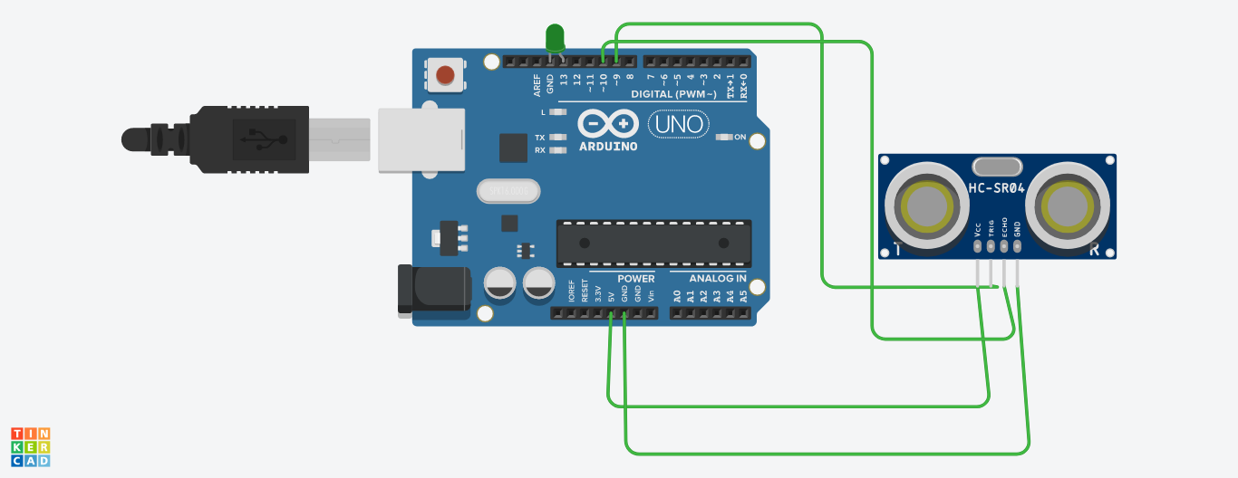

**THEORY**

**CONCEPT USED:-**

Here the concept of Ultrasonic Distance Sensor is being used which determines the distance to an object by measuring the time taken by the sound to reflect back from that object. Also we get to know about the use of Arduino UNO along with LED.

**LEARNING AND OBSERVATION:-**

1. Here we learned about the use of Ultrasonic Distance Sensor and its connections with Arduino UNO.
2. We will observe that the LED will blink when distance from the sensor attached at the gate is less than or equal to 100cm and it will not blink when the distance is more than 100cm.
3. We will connect one pin to ground and one pin to 5V.

**PROBLEMS AND TROUBLESHOOTING:-**

1. I faced problem while setting the timings or delay timings as the LED was blinking even when the distance was more than 100cm.

**SOLUTION:-**

1. I looked into the code carefully so as to find the mistake then I found my mistake and I rectified it.

**PRECAUTIONS:-**

1. Circuit should be neat and clean and the connections should be tight.
2. Circuit should be cross checked twice and connections should be done properly.
3. Hands should not be wet while working with the circuit to prevent shock.

**LEARNING OUTCOMES:-**

1. We also learn about how to make hardware using this sensor and how to write the program to simulate Arduino UNO.
2. We also get to know that on what principle does the home security sensing system works.